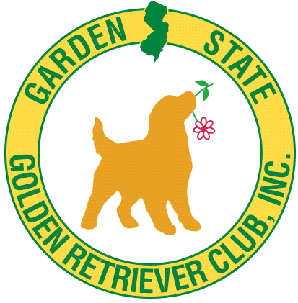 **GARDEN STATE GOLDEN RETRIEVER CLUB INC.**

**MATCH SHOW Saturday April 26, 2025**

**NEW**: **All Sporting Breeds for CONFORMATION**

**Rain or Shine* *Entries: day of show only

Location: North Branch Park, 355 Milltown Rd, Bridgewater, NJ

**\*\*CONFORMATION & JR. SHOWMANSHIP\*\***

**Judge: Hank Skully**

Entries accepted from 10AM till Judging Time at 1 PM

**Breed Entry Fee: $10.00 Each** **Jr. Show: no fee if entered in another class

Prizes for each class: puppies 3-6, 6-9, 9-12 months. Adult 12-18 mos

Open and Veterans. Jr Show Novice (Jr 8-12yr), Senior (13-17yr)

Rules: Dogs with Major can’t enter. Prof.handler may only enter their own dog.

**\*\*DEMOS\*\***

**\*\*NEW:** various **Demos** performed: times subject to change

**Breed Handling 12pm Grooming 9am Obedience 10am**

**Field Work 11am Nose work(scent)1030am**

**\*CGC Canine Good Citizen Demo *testing available-sign up day of**

Also Kids/Dog Games

**++Do Not Forget chairs & water. ++ No food available**

**Directions**: I 287 North or South to Exit for Rt202/206. Take Rt202 approx 2.5 miles to Milltown Rd. Bear right off Rt 202 South onto Milltown Rd. Park is about 1/2 mile on left. From Flemington Circle Rt 202 North about 10 Miles to Milltown jug handle. Park is on your left

**INFORMATION**: Kathy [rrpups1943@gmail.com](mailto:rrpups1943@gmail.com) Betty [bkopetz@verizon.net](mailto:bkopetz@verizon.net)