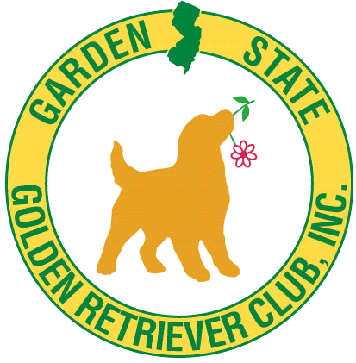 GARDEN STATE GOLDEN RETRIEVER CLUB, Inc.
MATCH SHOW April 27, 2024
Location: North Branch Park, 355 Milltown Rd., Bridgewater, NJ
Goldens ONLY Rain or Shine Entries Day of show only
** CONFORMATION & JR. SHOWMANSHIP**
ENTRIES Accepted from 9:00AM till Judging Time 1:00PM
JR. Showmanship: Judge: TBA Judging: 1:00PM
Classes: Novice or Open: Junior (8-12yrs), Senior (13-17 Yrs.)
CONFORMATION: Judge: TBA Judging: after Jr Showmanship
Puppy Classes: 3-6, 6-9 & 9-12 months
Adult Classes: 12-18 mos, Bred-By, American Bred, Open & Veterans
Entry and Prizes & Rules: Dogs with Major cannot enter. Prof. Handler may only show their own dog.
Do not forget chairs and water. No Food Available
Breed Entries: $10.00 Each ** JR. Showmanship: no fee if entered in another class
Prizes: BOB, BOS in Jr & Sr Puppy and Adult, Best Vet & Best Jr Handler-
receive Rosettes & Ribbons for Class Placements 1-4.
Directions: I 287 North or South to Exit for Rt202/206. Take Rt202 approx. 2.5 miles to Milltown Rd. Bear right off Rt 202 South onto Milltown Rd. The park is about 1/2 mile on left. From Flemington Circle Rt 202 North about 10 Miles to Milltown jug handle. The park is on your left.
INFORMATION: Betty bkopetz@verizon.net Kathy rrpups1943@gmail.com

